Republic Polytechnic

**A107 Physics**

**Worksheet 13: The Material Matters!**

**Introduction**

1. You noticed how a golf ball deforms when it is hit by a golf club (From **Video 1**). List five examples of objects changing shape in everyday life and what might cause them to do so.

* A hammer beating a piece of metal.
* A string forming a catenary under its own weight.
* A car breaking into pieces as it hits a steel wall.
* A trampoline deforming as someone jumps on it.
* A skyscraper swaying in the breeze.

**Action of force and deformation of materials**

1. From everyday activities like stretching rubber bands, bending wires, or pulling springs – we are all familiar with the fact that objects can deform or change shape under the action of forces. Now let us consider what happens when we apply a downward force on wire hanging from a stand.



Light downward diagonalLight downward diagonalLight downward diagonal





Figure. 1. Wire suspended from a stand, with a mass attached at the end of the wire

Figure 1 above shows a series of actions done to a wire suspended from a stand.

In scenario 1, the wire is left suspended from a stand.

In scenario 2, a mass of 1 kg is attached to the end of the wire.

In scenario 3, a mass of 2 kg is attached to the end of the wire.

1. How would you expect the length of the wire to differ in the 3 scenarios above?

The more weight attached, the more the wire stretches.

1. Would the length of the wire be different across the 3 scenarios?

Yes. Scenario 3 will be the longest as it carries the heaviest weight, scenario 1 will not change as it carries no weight.

1. If there is difference in length of the wire, which of the scenario would the length of the wire be the longest and why?

Scenario 3. When we take a wire, something that we are so familiar with now, and the wire has length in a relaxed state, we can extend the wire with some force that we apply and in this case we are using a weight to pull it. The more force pulling the wire down, the more normal strain observed.

This is also scientifically proven. The basic law of elasticity is Hooke's law. If a force F is applied to an elastic object (such as wire), the object will undergo a change in length Dx which will be directly proportional to F . Mathematically, this can be expressed as:

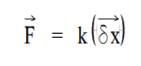

1. Watch **Video 2** in the problem package. From **Video 2**, verify whether your answer to Q2 is correct.

It is correct. This is because Young's modulus represents the factor of proportionality in Hooke's law, which relates the stress and the strain. However, Hooke's law is only valid under the assumption of an elastic and linear response. Young’s modulus is a measure of the ability of a material to withstand changes in length when under lengthwise tension or compression. Sometimes referred to as the modulus of elasticity, Young’s modulus is equal to the longitudinal stress divided by the strain.

1. Now let us consider the situation as shown below in Figure 2. Two wires of equal length made of same material but of different thickness are suspended on a stand.



Light downward diagonalLight downward diagonal







Figure. 2. Wires of different thickness with mass attached at the end of the wire

A mass of 2 kg is subsequently hung over the free end of both the wires.

1. How would you expect the extension of the two wires to differ when the mass of 2 kg is attached to the end?

The thinner wire will stretch more.

1. Which of these two wires will extend more and why?

The thinner wire. It is because when considering the thickness of spring wire, a setup with a thicker wire is stiffer.

1. Watch **Video 3** in the problem package. From **Video 3**, verify whether your answer to Q4 is correct.

Yes it is correct.

There are basically four factors that affect the elasticity of a spring.  
  
Length of wire – A shorter wire is a stiffer wire.  
Thickness of wire – A thicker wire is a stiffer wire.  
Diameter of coils of spring wire(if applicable)– A spring with a smaller diameter of coils is a stiffer spring.  
Material of wire – Wires made of different materials have different stiffness (e.g. steel wire is stiffer than copper wire)

1. From the two videos, we know that when a tension force is applied to a wire, the length of the wire will extend.

Would the extension of the wire be restricted to the free end of the wire or would the extension of the wire be spread across the entire wire?

It would be spread evenly across the wire.

1. Watch **Video 4** in the problem package. The attached file “Extension of wire.doc” is the snapshot pictures of the starting scene and ending scene of **Video 4**.



From **Video 4**, verify whether your answer to Q6 is correct.

This also has been scientifically proven.

Stress is defined as the force per unit area of a material.  
  
i.e. Stress = force / cross sectional area:  
  
Definitions of Stress, Strain and Young's Modulus  
  
where, σ = stress, F = force applied, and A= cross sectional area of the object.  
  
Units of s : Nm-2 or Pa.

1. From your discussion from Q1 – Q7, summarise the ideas you have obtained.

* When an elastic body is deformed, work is done. The energy used up is stored in the body as strain energy and it may be regained by allowing the body to relax. All materials deform to some extent when subjected to a stress (a force per unit area). Elastic materials have internal forces which restore the size and shape of the object when the stress is removed. If the deformation, or strain (the ratio of the change in length to the initial length), is directly proportional to the applied stress and if it is completely reversible so that the deformation disappears when the stress does, then the material is said to be perfectly elastic. An elastic material exerts a restoring force when stretched and this can lead to oscillation when the elastic material is attached to a mass.
* We now go beyond statics and kinematics. Stresses produce deformations because real materials are not infinitely rigid. Deformations are measured by strains. Integration of strains through space gives displacements, which measure motions of the particles of the body (structure). As a result the body changes size and shape.
* There are two types of strain involved in today’s problem statement which are Normal Strain and Shear Strain. Normal vs. Shear. Normal strain measures changes in length along a specific direction. It is also called extensional strain as well as dimensional strain. Shear strain measures changes in angles with respect to two specific directions.
* When a stretching force (tensile force) is applied to an object, it will extend. We can draw its force - extension graph to show how it will extend. Note: that this graph is true only for the object for which it was experimentally obtained.

**The physics of materials**

1. The distribution of the force exerted over the cross-sectional area normal to the applied force is known as the stress (generally denoted by $σ$ with the S.I. units of Pa or N/m2).

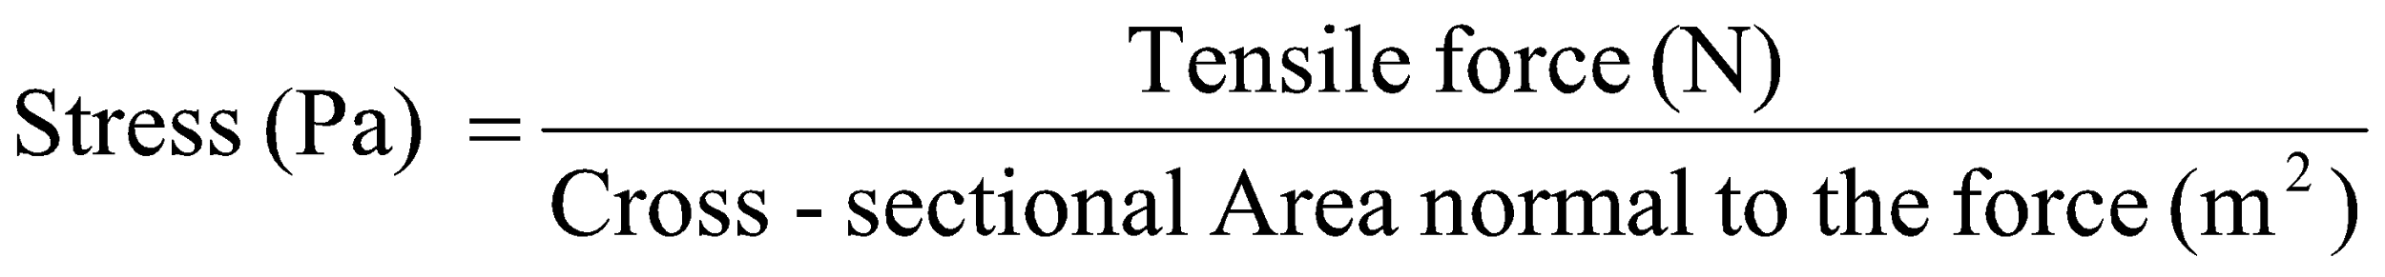



Force

Wall

Cross-sectional Area

Figure 3. Consideration of stress: Cross-sectional area is perpendicular to applied force

Which of the wires in Q4 experiences a higher stress? Why? What is the unit for stress?

The circle.

Stress = force / cross sectional area

This is because since the circle has a smaller cross sectional area and since we are assuming that equal force is applied to both rods, the stress obtained is higher due to a smaller cross sectional area.

1. When stress is applied across wire, the wire will extend in length (deformation). Scientists measure the degree of deformation by a measure called **strain**. Figure 4 shows the strain undergone by a wire when it is subjected to stress.



Applied

stress

Before:

Original distance between markings, *L*0

Figure 4. Concept of strain

Wall

Final distance between markings , *Lf*

Change in length, *δ*= *Lf – L*0

After:

Strain, *ε*, is defined as: 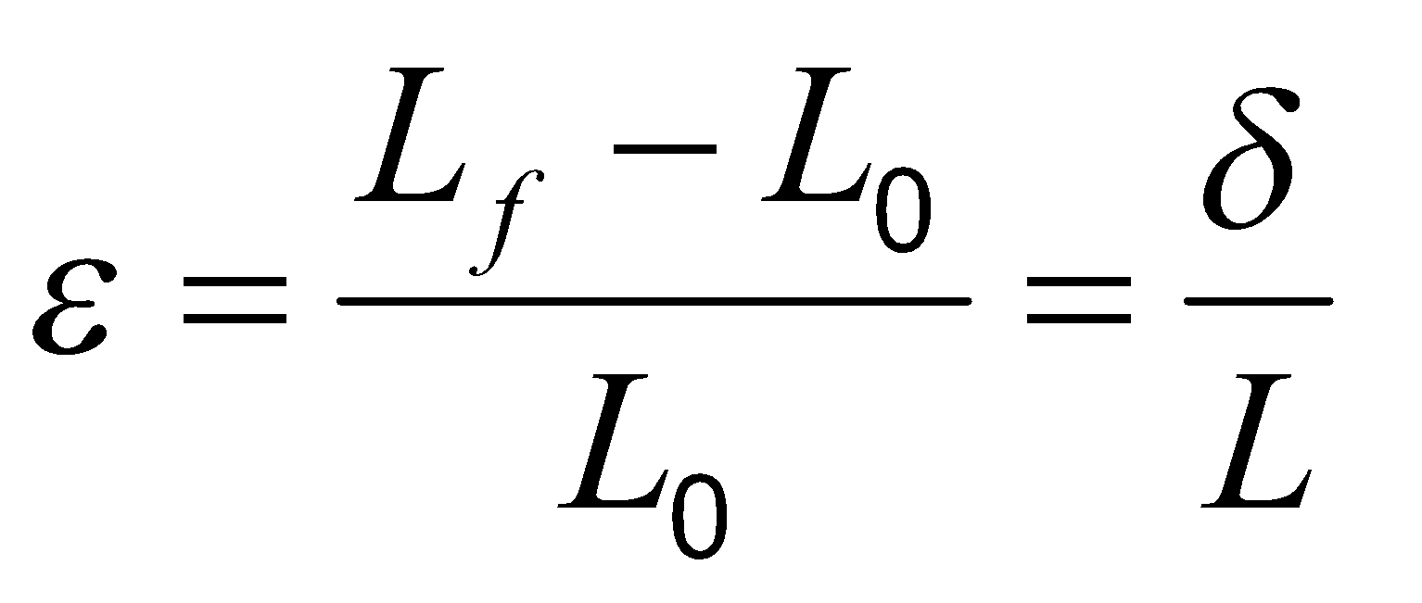

*L*f = final length

*L*0 = original length

*δ* = change in length

1. What is a possible unit of strain?

It is measured in reciprocal of seconds (s−1).

1. Find the strains incurred for Rod A and Rod B in Table 1:

Table 1: Comparison of strains

|  |  |  |
| --- | --- | --- |
|  | Rod A | Rod B |
| Original length (m) | 1.0 | 2.0 |
| Final length (m) | 1.1 | 2.2 |
| Strain | 0.1 | 0.1 |

1. Comment on the change in overall length and the strain for each of the two rods.

Even though Rod A and Rod B’s length is different, the strain is the same.

1. A bar undergoes a strain of −0.2 due to a force. When would the strain be negative?

When there is a compression. In other words, reduction in size.



1. A rod of length of 20 cm and diameter of 5 mm is subjected to a tensile (pulling) force of 1540 N, and the rod extended by 0.5 mm.



Force = 1540 N

wall

Figure 5. Rod pulled with a force of 1540 N

* + - 1. What is the stress experienced by the rod?

stress=force/area

1540/TT(2.5)^2

78.43

* + - 1. What is the strain in the rod?

strain=5.5-5/5=0.1

**Stress-Strain Relationship: Linear, non-linear**

1. The stress-strain graph for a rod has a shape as shown below:



* + - 1. When loaded from zero up to Point (a), the graph is a straight line. Scientists call Point (a) the proportional limit. What could be the reason for this name?

A yield strength or yield stress is the material property defined as the stress at which a material begins to deform plastically whereas yield point is the point where non-linear

(elastic + plastic) deformation begins. Prior to the yield point the material will deform elastically and will return to its original shape when the applied stress is removed. Once the yield point is passed, some fraction of the deformation will be permanent and non-reversible.

* + - 1. If the stress did not go beyond Point (b), when the force is released, the rod retraces back the same stress-strain path to the original shape. This kind of regaining of shape is known as elasticity. Propose a name for the limit Point (b).

The yield point.

* + - 1. Once a material is loaded beyond Point (b), it undergoes permanent deformation which means that the material does not regain its original shape and size upon removal of the load. This type of deformation is termed as “plastic deformation”. Ductile materials like mild steel are known to undergo large plastic deformation before failure due to imposed load. What happens to a deforming material when it reaches the Fracture Point (c), as indicated in Figure 6?\

A fracture is the separation of an object or material into two or more pieces under the action of stress. The fracture of a solid usually occurs due to the development of certain displacement discontinuity surfaces within the solid. If a displacement develops perpendicular to the surface of displacement, it is called a normal tensile crack or simply a crack; if a displacement develops tangentially to the surface of displacement, it is called a shear crack, slip band, or dislocation. Fracture strength or breaking strength is the stress when a specimen fails or fractures.

1. The following stress-strain graph is for another material. Comment on this material.





A s material has a high Young's modulus and changes its shape only slightly under elastic loads (e.g. diamond). A flexible material has a low Young's modulus and changes its shape considerably

**Characteristic properties for different materials**

1. The following stress-strain curves are for three bars of the same size and shape but made of different materials.

Figure 8. Stress-Strain behaviour of three different materials

1. Which material deforms most? Which deforms the least?

Material B deforms the most. Material A deforms the least.

1. Which is the stiffest? Which is the most flexible?

Material B has a high Young's modulus and changes its shape only slightly under elastic loads (e.g. diamond). Material B has a low Young's modulus and changes its shape considerably

1. The gradient of the stress-strain curve within the proportional limit gives the Young’s modulus of the material.
2. Referring to Figure 8, which has the largest Young’s modulus? Which has the smallest Young’s modulus?

Material A has the largest young modulus while Material B has the least

1. Briefly describe what the Young’s modulus tells us about a material.

Stiffness and flexibility of a material depends on the young modulus of the material.The higher the young modulus, the stiffer the material

1. Comparing steel and rubber, which would have a larger Young’s modulus? Explain your answer.

The steel has the la6rger young modulus, it is more stiff compared to rubber, which is more elastic